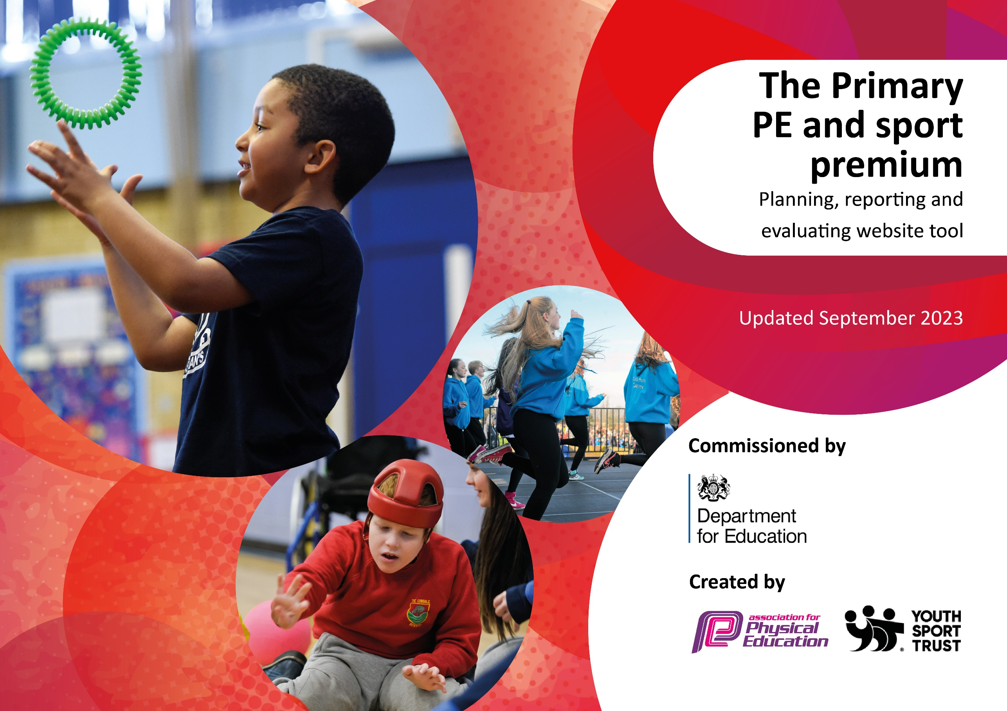

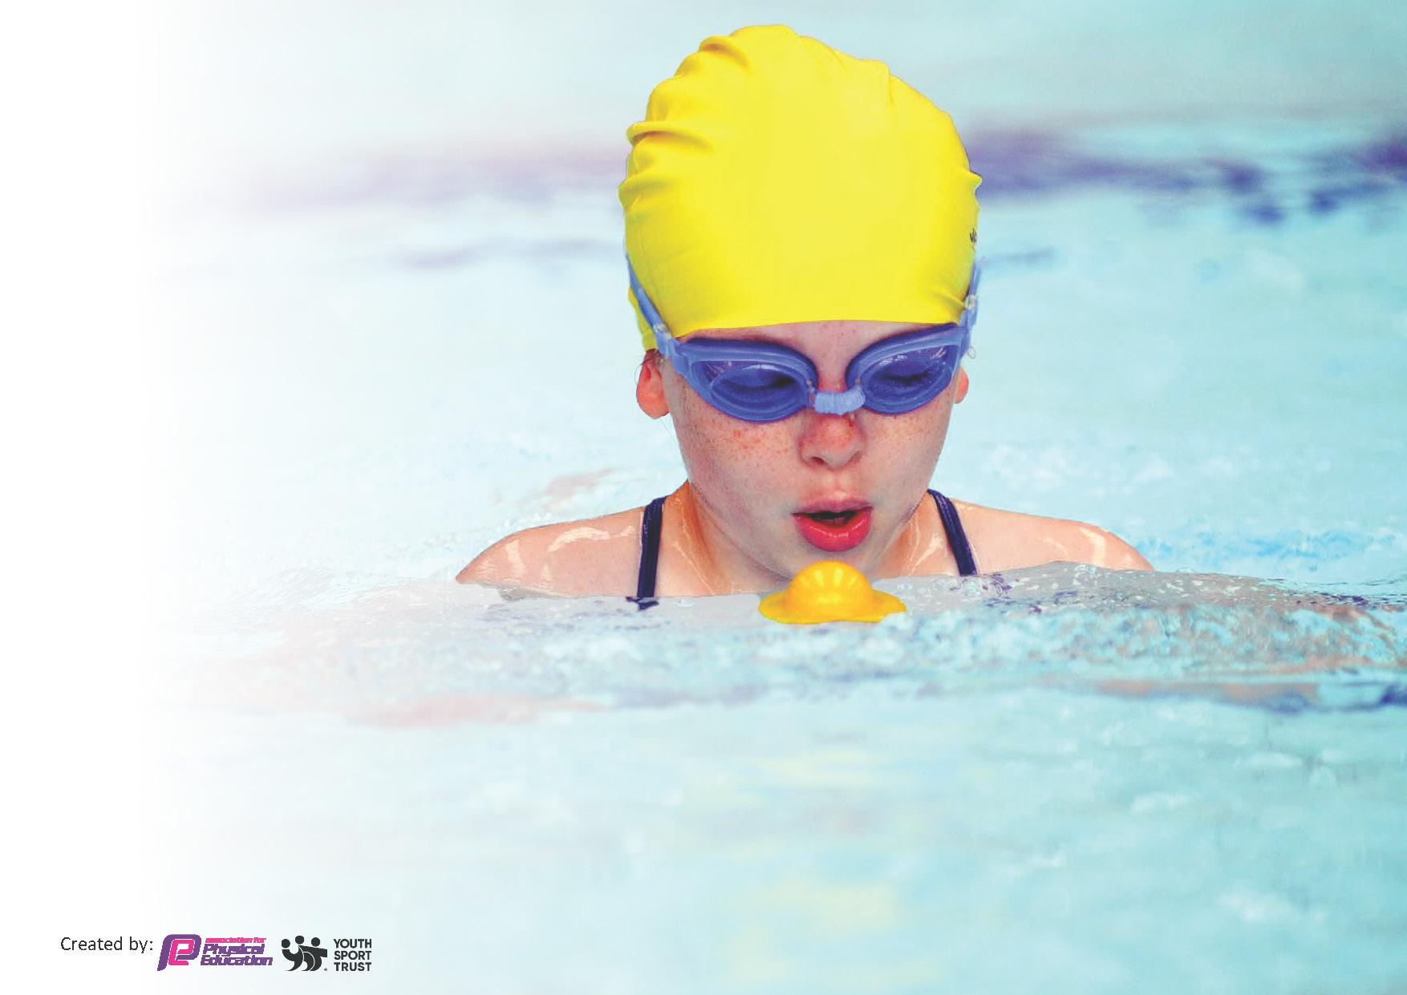
This template can be used for multiple purposes:
by:
- It enables schools to effectively plan their use of the Primary PE and sport premium
- It helps schools to meet the requirements (as set out in guidance) to publish information on their Primary PE and sport premium
- It will be an effective document to support Ofsted inspections enabling schools to evidence progress in Physical Education (PE) and evidence swimming attainment, which forms part of the PE National Curriculum. We would recommend schools consider
the Intent, Implementation and Impact of any spend, as examined within the Education Inspection Framework.

It is important that your grant is used effectively and based on school need.

Schools must use the funding to make additional and sustainable
improvements to the quality of the PE, School Sport and Physical Activity (PESSPA)
they offer. This means that you should use the Primary PE and sport premium to:

- Build capacity and capability within the school to ensure that improvements made now will benefit pupils joining the school in future years
- Develop or add to the PESSPA activities that your school already offers.

The Primary PE and sport premium should not be used to fund capital spend projects; the school’s core budget should fund these. Further detail on capital expenditure can be found in the updated Primary PE and sport premium guidance.

The Primary PE and sport premium guidance, outlines 5 key priorities that funding should be used towards. It is not

necessary that spending has to meet all the key priorities, you should select the priorities that you aim to use any funding towards.

Although completing this template is not a requirement for schools, schools are required to publish details of how they spend this funding. Schools must also outline what the impact this funding has had on pupils’ PE and sport participation and attainment and how any spending will be sustainable in the future. All funding must be spent by 31st July 2024.

The Department for Education has worked closely with the Association for Physical Education (afPE) and the Youth Sport Trust (YST) to develop this template and encourages schools to use it. This template is an effective way of meeting the reporting requirements of the Primary PE and sport premium.
Review of last year’s spend and key achievements (2022/2023)

Activity/Action | Impact | Comments
To employ expert coaches to lead teaching of specific sport so that teachers and support staff can develop their own skill sets and confidence in leading and developing PE provision.  Provide teachers with a high quality scheme of work and resources to inform and support their planning and delivery of PE.  PE Subject leader to have up to date knowledge of statutory requirements for PE, latest research, best practice etc.  To increase opportunities for physical activity during playtime and lunchtime.  Raise the profile of the school by maximizing attendance at competitions, festivals and sporting events thus promoting pride in being a member of and representing Hertford St Andrew School.  Ensure that school environment supports opportunities to engage in competitive activities. | Teachers now have greater confidence to deliver a wide and varied sports curriculum, which can be easily adapted to be inclusive of our children with SEND.  Teachers have greater confidence in teaching the PE curriculum. We are well resources and resources are readily available to support delivery of high quality PE lessons.  Previous subject leader left the school in summer 2023; new subject leader has a developing knowledge and is more able to support teachers in their practice.  The goals are in daily use at playtimes and lunchtimes for competitive games of football. Our sports provider also runs a lunchtime football club who make use of the goals.  Children from YR – Y6 have attended events and festivals where children developed new skills, experienced new activities and had the chance to participate in friendly competition.  The school has provided tracks and pitches for summer events to take place. | Coaching has taken place throughout the year for all year groups from Y1-Y6. In addition, the coach has lead after school clubs for Y1-Y6 with a variety of different focuses.  Teachers familiar with the scheme and the progression of skills taught throughout the year. New staff for the upcoming year will need to be introduced and supported to deliver high quality PE lessons.  Subject leader to stay in place for the second year running, further embedding knowledge of curriculum and government expectations.  Children continue to play competitive football at play and lunch times.  Children, with diverse and physical needs, have participated with great enthusiasm, enjoyment and success.  Ongoing

Key priorities and Planning

Action – what are you planning to do | Who does this action impact? | Key indicator to meet | Impacts and how sustainability will be achieved? | Cost linked to the action
To employ expert coaches to lead  teaching of specific sport so that teachers and support staff can  develop their own skill sets and  confidence in leading and  developing PE provision. | All pupils YR-Y6  Cricket (Chance to Shine) Y1-6 6 x 1 hour for a half term plus afterschool club and 3 x young leader CPD  Complete Sports YR-6  1 day per week for half term plus lunchtime football club  Saracen’s Dance Club afterschool club run once per week YR – Y6  Play and lunchtime supervisors / teaching staff, coaches - as they need to lead the activity | Key indicator 1: Increased confidence, knowledge and skills of all staff in teaching PE and sport.  Key indicator 2 -The engagement of all pupils in regular physical activity – the Chief Medical Officer guidelines recommend that all children and young people aged 5 to 18 engage in at least 60 minutes of physical activity per day, of which 30 minutes should be in school.  Key Indicator 3: The profile of  PE and sport is raised across  the school as a tool for whole  school improvement .  Key indicator 4: Broader experience of a range of sports and activities offered to all pupils. | Pupils lead - Sports Crew Leaders  More pupils meeting their daily physical activity goal, more pupils encouraged to take part in PE and Sport Activities. | No cost  £9000  £1500
To purchase storage which allows equipment to be readily available, whilst keeping it clean and undamaged. | All staff and pupils | Key indicator 4: Broader experience of a range of sports and activities offered to all pupils. | Sustainable storage for the safekeeping of equipment. | £3000
To purchase large-scale construction and weaving equipment for the EYFS. | EYFS staff and pupils  SEND pupils who utalise the area during lunchtimes | Key indicator 2 -The engagement of all pupils in regular physical activity – the Chief Medical Officer guidelines recommend that all children and young people aged 5 to 18 engage in at least 60 minutes of physical activity per day, of which 30 minutes should be in school.  Key indicator 4: Broader experience of a range of sports and activities offered to all pupils. | Strong and durable equipment to develop fine and gross motor development in the outside learning area. | £2500
To purchase physical resources and furniture to equip our sensory circuit. | Our SEND and vulnerable pupils. | Key Indicator 3: The profile of  PE and sport is raised across  the school as a tool for whole  school improvement . | Sensory exploration is an important way for all children to meet their sensory needs whilst developing their physical well-being. | £750
To create a sensory corridor to support children with sensory processing issues or to help children to develop motor skills, balance, hand-eye coordination and spatial awareness. | All pupils | Key indicator 2 -The engagement of all pupils in regular physical activity – the Chief Medical Officer guidelines recommend that all children and young people aged 5 to 18 engage in at least 60 minutes of physical activity per day, of which 30 minutes should be in school.  Key indicator 4: Broader experience of a range of sports and activities offered to all pupils. | Sensory exploration is an important way for all children to meet their sensory needs whilst developing their physical well-being.  Provides a construction breakout area for those pupils who require an adapted curriculum. | £10,000
Maintain high levels of attendance to inter-school competitions and other events available. | All pupils  Events included:  - Every1InFestival  - Rapid Fire Cricket  - Infant Agility  - Wodson Games  - International Carousel  - Dynamo Cricket  - Mini Tennis  - Ultimate Frisbee Festival  - Hertfordshire Celebration Day | Key Indicator 2. Engagement  of all pupils in regular physical  activity.  Key Indicator 3: The profile of  PE and sport is raised across  the school as a tool for whole  school improvement.  Key indicator 4: Broader  experience of a range of sports  and activities offered to all  pupils. |  | Transport costs £1000

Timetable a broad range of  experience of sport and physical  activities led by external  professionals. | EYFS pupils – Bikeability Programme in association with Herts Disability Sports Foundation  All pupils - Street dance afterschool club  run by Saracen’s Sports  Foundation  All pupils -Dance themed workshops  Pupils to participate in The Showdown4 – Dance event to be held at Tottenham Hotspur Stadium. | Key indicator 2 -The engagement of all pupils in regular physical activity – the Chief Medical Officer guidelines recommend that all children and young people aged 5 to 18 engage in at least 60 minutes of physical activity per day, of which 30 minutes should be in school.  Key indicator 4: Broader experience of a range of sports and activities offered to all pupils. | Children had the opportunity to  take part in a range of  sporting activities that they had not previously experienced.  They were supported by professionals to develop their  confidence and skills. | £2000

Activity/Action |  | Comments/cost
Purchased new sport equipment, sustainable storage, mindfulness and wellbeing resources  Year 6 (catch-up) and Year 5 swimming lessons  Herts and Ware Sports Partnership – increased participation in sporting competitions for all ages, upskilling of PE lead  Showdown4 – dance event, experience of performance in major stadium event, participation in spectator event  Travel  School environment – to support competitive activities and sports day as a whole community event.  Sensory/mindfulness equipment  Redevelopment of corridor – sensory and movement pathway in order to promote motor skills, movement and sensory organisation for children ‘hard to reach’ or with SEND  EYFS outdoor equipment – motor skills development  Expertise coaching - Complete Sports and Saracens | Key indicator 4: Broader experience of a range of sports and activities offered to all pupils.  Key Indicator 5: Increased participation in competitive sport  Key Indicator 3: The profile of PE and sport is raised across the school as a tool for whole school improvement.  Key indicator 2 -The engagement of all pupils in regular physical activity – the Chief Medical Officer guidelines recommend that all children and young people aged 5 to 18 engage in at least 60 minutes of physical activity per day, of which 30 minutes should be in school.  Key indicator 1: Increased confidence, knowledge and skills of all staff in teaching PE and sport. | £3000  £1760  £1000  £1200  £500  £2000  £10,000 (broken down into: refurb, resources, planning, set up costs, training, resources)  £10,000

Swimming Data
Meeting National Curriculum requirements for swimming and water safety.

Question | Stats: | Further context  Relative to local challenges
What percentage of your current Year 6 cohort can swim competently, confidently and proficiently over a distance of at least 25 metres? | 44 % | For the majority of children, there are no external lessons.  High proportion of children with SEND who were reluctant to swim
What percentage of your current Year 6 cohort can use a range of strokes effectively [for example, front crawl, backstroke, and breaststroke]? | 39 %

What percentage of your current Year 6 cohort are able to perform safe self-rescue in different water-based situations? | 39 %
If your schools swimming data is below national expectation, you can choose to use the Primary PE and sport premium to provide additional top-up sessions for those pupils that did not meet National Curriculum  requirements after the completion of core lessons. Have you done this? | Yes/No | Free access to pool and transport provided by local independent school – but access is time limited
Have you provided CPD to improve the knowledge and confidence of staff to be able to teach swimming and water safety? | Yes/No | Current staff member was trained swimming coach – took lessons with staff support

Signed off by:

Head Teacher: | Ms. Rebecca Sutherland Cooper
Subject Leader or the individual responsible for the Primary PE and sport premium: | Mrs. C Sampson
Governor: | Mr. Stuart Aldridge – Chair of Governors
Date: | 18th July 2024

