**Parents Guidelines and Responsibilities**

Parents must have signed and completed the Walking Bus Agreement before their child is allowed to travel on the walking Bus.

It is the parent’s responsibility to advise the Driver of any changes to their child’s regular travel pattern

Parents are responsible for their child’s safety on the way to the designated bus stops. They should ensure their child is dressed appropriately and arrive at the collection point on time

Parents should ensure that their child understands the need for sensible behaviour and following instructions given by the Driver and Conductor

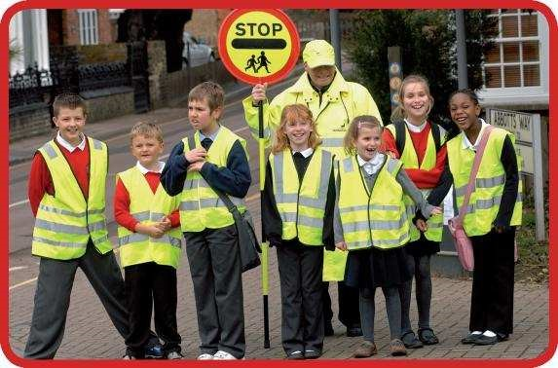**Child’s Responsibility**

Children MUST wear their high visibility vest when using the Walking Bus

They must behave sensibly and follow instructions

**Walking Bus Information**

The Walking Bus is operated and managed by the school.

Volunteers will have DBS clearance before escorting the children.

Parents must sign a consent form and provide emergency contact details.

There will be the correct adult to child ratio and everyone will wear high visibility vests.

Each bus route will have a register of children who intend to use it with their contact details.

The route walked has been assessed by the school and the Hertfordshire County Council`s Area Road Safety Officer.

The Hertfordshire County Council`s Area Road Safety Officer provides road safety training with the volunteers. There will be a “Driver” leading the Walking Bus and a “Conductor” walking at the rear to ensure the children can be seen and kept under control.

Hertfordshire County Council provides public liability insurance cover.

The location of the bus stops will have been identified during the risk assessment. It is here that children will join.

The Walking Bus will run whatever the weather.

**The bus will operate to a firm timetable and will not wait for late comers in the morning, even if certain children are expected to travel.**

FOR MOR INFORMATION ON WALKING BUSES PLEASE SEE

www.hertfordshire.gov.uk/walkingbus